**Университет ИТМО**

Кафедра информатики и прикладной математики

**Лабораторная работа №3**

Выполнила:

Бриль Марина P4217

# 

### 

### **Структура исходных данных**

The instances were drawn randomly from a database of 7 outdoor images. The images were handsegmented to create a classification for every pixel.

Each instance is a 3x3 region.

Attribute Information. Float values:

1. region-centroid-col: the column of the center pixel of the region.

2. region-centroid-row: the row of the center pixel of the region.

3. region-pixel-count: the number of pixels in a region = 9.

4. short-line-density-5: the results of a line extractoin algorithm that

counts how many lines of length 5 (any orientation) with

low contrast, less than or equal to 5, go through the region.

5. short-line-density-2: same as short-line-density-5 but counts lines

of high contrast, greater than 5.

6. vedge-mean: measure the contrast of horizontally

adjacent pixels in the region. There are 6, the mean and

standard deviation are given. This attribute is used as

a vertical edge detector.

7. vegde-sd: (see 6)

8. hedge-mean: measures the contrast of vertically adjacent

pixels. Used for horizontal line detection.

9. hedge-sd: (see 8).

10. intensity-mean: the average over the region of (R + G + B)/3

11. rawred-mean: the average over the region of the R value.

12. rawblue-mean: the average over the region of the B value.

13. rawgreen-mean: the average over the region of the G value.

14. exred-mean: measure the excess red: (2R - (G + B))

15. exblue-mean: measure the excess blue: (2B - (G + R))

16. exgreen-mean: measure the excess green: (2G - (R + B))

17. value-mean: 3-d nonlinear transformation

of RGB. (Algorithm can be found in Foley and VanDam, Fundamentals

of Interactive Computer Graphics)

18. saturatoin-mean: (see 17)

19. hue-mean: (see 17)

Classes:

* brickface,
* sky,
* foliage,
* cement,
* window,
* path,
* grass.

### **Ход работы**

Визуализируем вначале два признака value-mean и hue-mean. Также для большей наглядности попробуем визуализировать по трём признакам value-mean, hue-mean и saturatoin-mean.

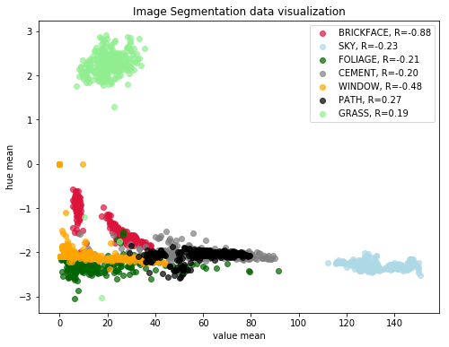

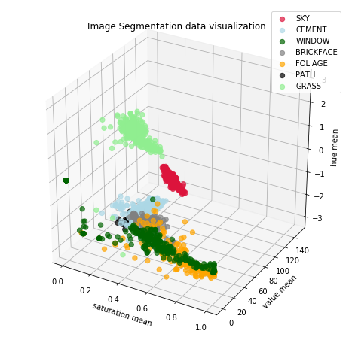

Визуализация в трёхмерном пространстве особой нагляднотси, к сожалению не принесла.

Выполним разбиение классов с помощью LDA и осуществим визуализацию

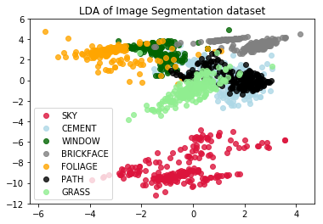

Осуществим классификацию с помощью метода LDA:

Classification accuracy for train data = 85.58%

Classification accuracy for test data = 82.54%

Осуществим классификацию с помощью метода QDA:

QDA

Classification accuracy for train data = 86.12%

Classification accuracy for test data = 81.43%

### 

### **Вывод**

Как видно из работы, оба методы классификации показали одинаковый хороший результат.